**612/1**

**IPS ART & CRAFTS**

**(STUDIO TECHNOLOGY)**

**Paper 1**

**Jul / Aug 2019**

2 hours

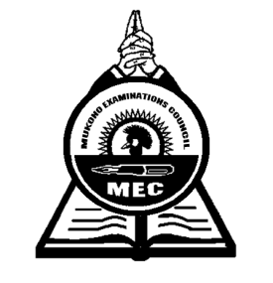

**MUKONO EXAMINATION COUNCIL**

**Uganda Certificate of Education**

**IPS ART AND CRAFTS**

**(STUDIO TECHNOLOGY)**

Paper 1

2 hours

**INSTRUCTIONS TO CANDIDATES**

*Answer* ***all*** *questions*

*Drawings and Diagrams should be used where necessary*

1. (a) Define the term balance  ***(02 marks)***

(b) With illustrations, explain any two types of balance  ***(05 marks)***

2. (a) What is meant by the term silk screen printing  ***(02 marks)***

(b) List four materials and four tools used in silk screen printing ***(02 marks)***

1. Explain the following methods used in basketry
2. Twinning  ***(02 marks)***
3. Coil ***(02 marks)***
4. Wicker work ***(02 marks)***

4 (a) Define the term leather ***(02 marks)***

(b) Give two examples of leather work  ***(02 marks)***

(c). List three materials and three tools used in the making of leather craft ***(06 marks)***

5 (a) Explain five advantages of using cement as material for sculpture ***(05marks)***

(b) Name and draw four tools used in cement sculpture ***(04 marks)***

6 (a) Explain the following terms;

1. Plain Weave ***(02 marks)***
2. Twill weave  ***(02 marks)***

(b) Mention four materials and four tools used in weaving ***(04 marks)***

7 (a) Describe the term waxing as used in batik  ***(03 marks)***

(b) Give four challenges of batik as a method of fabric decoration ***(04 marks)***

8. (a) Define the term papier Mache? ***(02 marks)***

(b) Explain the process of making papier Mache ***(06 marks)***

9. (a) What is a kiln ***(02 marks)***

(b) Explain three types of kilns ***(03 marks)***

10. Mention six factors that have promoted crafts to your community ***(06 marks)***

***End -***